Kitchen Drawer Organizer

Version 1.0

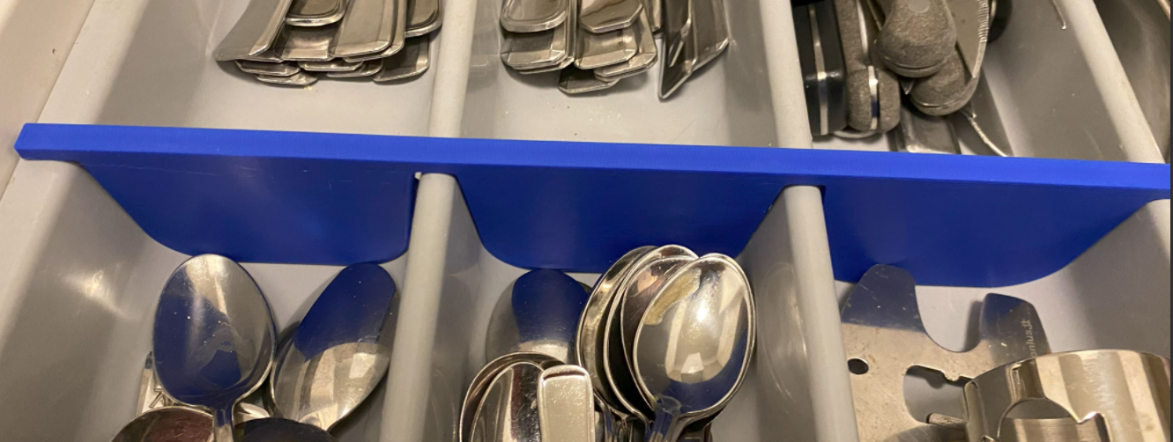

Project Goals
I was sick of all my spoons and silverware moving around in the kitchen drawer, so I decided to create an physical barrier to replace the old ones that now are wearing out.

Kitchen Drawer Organizer Sketch

Top View
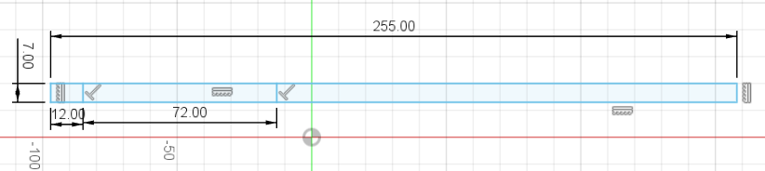

Side View
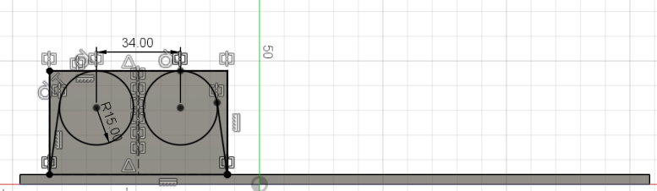

Side slot
This is a side pin that is used to match a slot in the kitchen drawer. This is critical to keep the organizer in place.
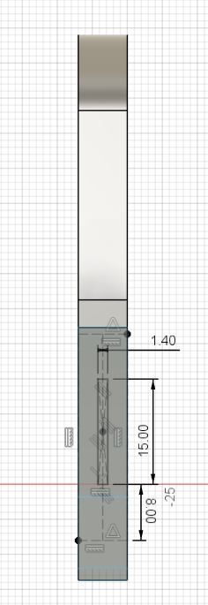

Reinforcement holes
To create a more rigid structure I add 4 holes in the top beam.
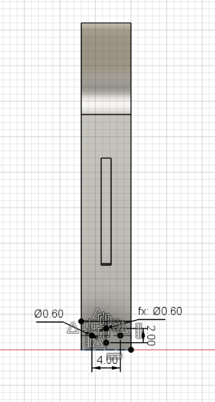

Kitchen Drawer Organizer 3D Model
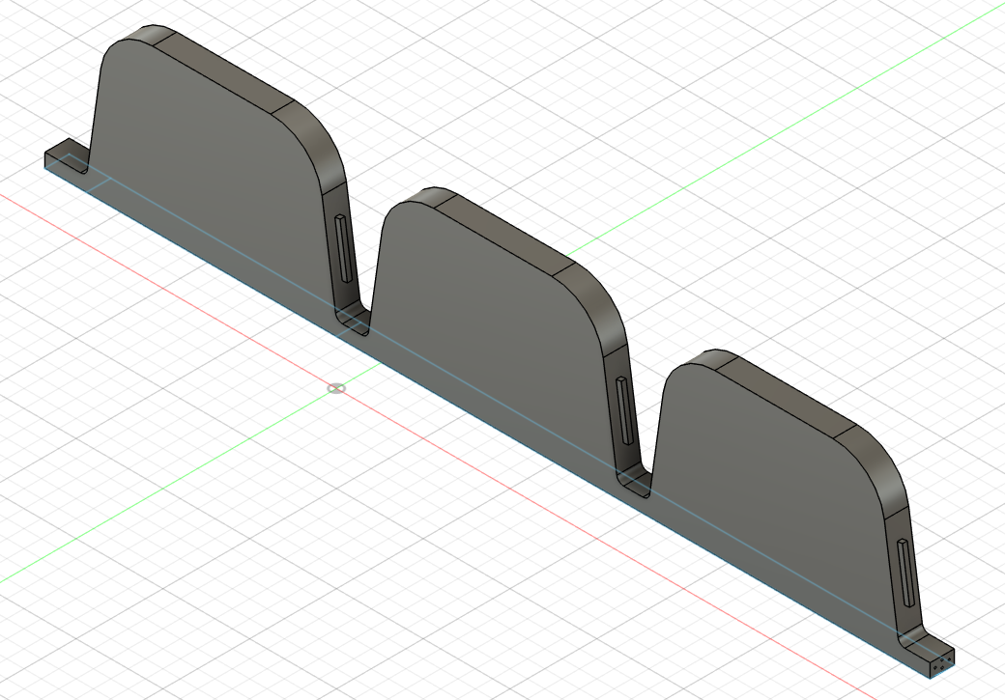

3D Printer Layout

Final Result

